**CHE517 ADVANCED PROCESS CONTROL**

**FINAL EXAM**

Professor Shi-Shang Jang Jan. 15, 2013

**Problem #1 (20%)**

Consider the following process with three inputs and three outputs.



Using Bristol’s relative gain array, select the control loops with minimum steady state interaction.

**Problem #2 (20%)**

Derive an IMC controller for the following process:

$$G\left(s\right)=\frac{4(s+1)(2s-1)}{(3s+1)(7s+1)}$$

Draw a block diagram for the whole structure.

**Problem #3 (20%)**

Derive a pulse transfer function (z-domain) for the following plants with a zero order hold with different sampling time (T):

1.  (7 points)
2.  (7 points)
3.  (6 points)

**Problem #4 (20%)**

Consider the drying process shown in the following Figure. In this process, wet paper stock is being dried to produce the final paper product. The drying is done using hot air;this air is heated in a heater in which fuel is burned to provide the energy. The controlled variable is the moisture of the paper leaving the drier. Figure below shows the original control scheme proposed and installed.

1. A few weeks after start-up, the process engineer noticed that even though the moisture controller was keeping the moisture within certain limits from set point , the oscillations were more than desired. After searching for possible caused and making sure that the moisture controller was well tuned, they found that the hot air temperature leaving the heater varied more than had been assumed during the design stage. These variations were attributed to daily changes in ambient temperature and possible disturbances in the combustion chamber of the heater. Design a control scheme to maintain the hot air temp. at the desired value to help maintain moisture set point
2. The control scheme just described significantly improved the moisture control. A few weeks later, however, the operators complained that every once in a while , the moisture would go out of set point considerably , though the control scheme would eventually bring it back to set point .This disturbance would require that the paper produced during this period be reworked, so it represented a production loss. After searching through the production logs, the process engineers discovered that changes in inlet moisture were scheme that compensates for these disturbances. There transmitter, with a range of 5 to 20 moisture %, available to measure the inlet moisture. 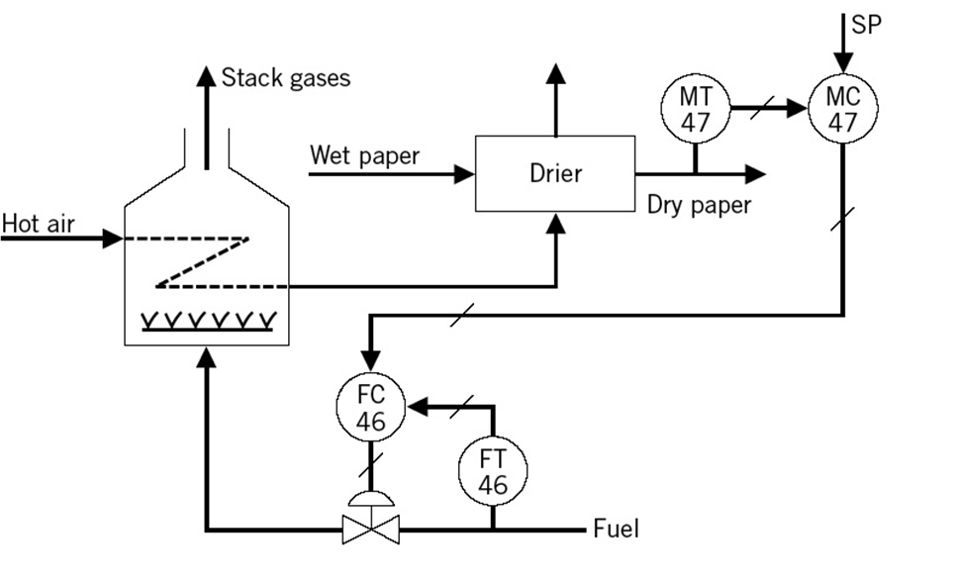

**Problem #4 (25%) – Take home**

1. Construct a pulse response model for the following process:



with H=10. H=20, H=30 respectively.

1. Test the accuracy of the model using random inputs and comment the accuracies of the models.
2. Considering the following process, can you also construct a pulse response model?



Choose an appropriate horizon, and test the accuracy.